1. Write a trigger to notify back order quantity (ROL-SOH) with suitable

message Whenever SOH crosses ROL.

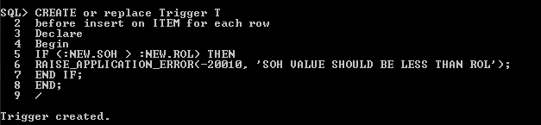

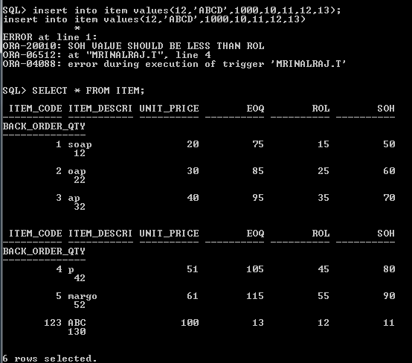

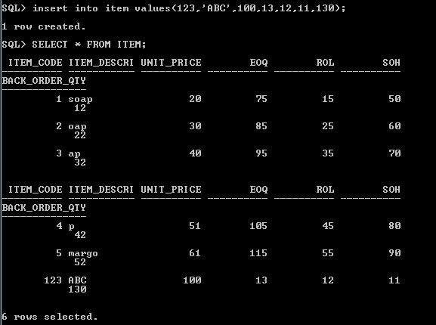

2. Write a Stored procedure to display the details of ITEM which are

ordered on specific Order-Date.

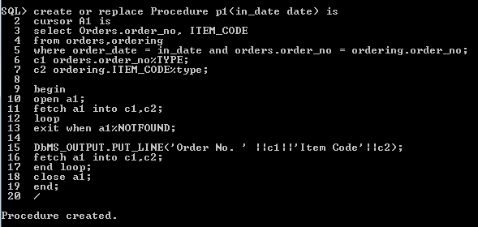

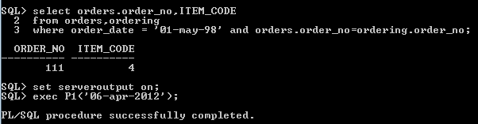

3. Write a Stored procedure which accepts Item-Code and vendor-no as

parameter and displays the number of orders on the Item ordered by

the vendor.

